



Service Level Agreement
Parties
(1) YORK ST JOHN UNIVERSITY incorporated and registered in England and Wales with company number 04498683 whose registered office is at Lord Mayor’s Walk, York, YO31 7EX

(2) NAME and Address

Part A: Conditions

- Duration

This agreement shall commence on 1 August 2025 and continue until 31 October 2026, unless terminated earlier by the mutual agreement of the parties.

- Mission

The mission of the Inspiring Choices programme is to work with identified target schools and colleges in York and North Yorkshire. As a partnership, Inspiring Choices is part of a wider initiative, Uni Connect, which is funded by the Office for Students (OfS), an independent regulator for higher education in England, accountable to the Department for Education (DfE). Uni Connect aims to reduce the gap in higher education (HE) participation between the most and least represented groups. Inspiring Choices is one of 29 partnerships across the country to receive funding to undertake outreach activity in geographical areas where participation of young people in HE is lower than might be expected given the GCSE results of the young people who live there.

- Objectives

The purpose of this agreement is to set out the key elements of cooperation between York St John University as the lead institution, and its partners, in relation to the promotion and support of the Inspiring Choices programme goals.

  - The programme aims are to:

- Contribute to reducing the gap in higher education participation between the most and least represented groups.
- Equip young and adult learners from underrepresented groups to make an informed choice about their options in relation to the full range of routes into and through higher education and to minimise the barriers they may face when choosing the option that will unlock their potential.
- Support a strategic local infrastructure of universities, colleges and other partners that can cut through competitive barriers, offer an efficient and low-burden route for schools and colleges to engage, and address outreach ‘cold spots’ for underrepresented groups.
- Contribute to a stronger evidence base around ‘what works’ in higher education outreach and strengthen evaluation practice across the sector.

  - This agreement sets out the requirements of Inspiring Choices’ partners, plus commissioned third parties to:

- Provide appropriate resources to deliver the desired outcomes
- Work with the University and partners to undertake a range of activities with learners
- Provide appropriate data and agree data sharing protocols

  - Activities will be approved through a separate process which will be monitored through the governance structure as outlined in Section B.2. of this agreement.

- Spirit of the Agreement

  - The effectiveness of this Service Level Agreement is based on the grounds that both parties will enter the arrangements in the spirit of collaborative working and will seek to maximise the benefits of cooperation.

  - Both parties agree to work towards the objectives specified in this agreement.

  - All parties agree to be transparent on matters concerning the relationship and to declare any potential conflicts of interest.

  - Both parties agree to be responsible for ensuring that suitable communication systems are in place for areas served by the Inspiring Choices programme, and that these are used consistently and appropriately.

  - Activities and programmes developed for Inspiring Choices under this agreement will be subject to monitoring, tracking, reporting and evaluation requirements.

- Funding

  - Funding for bespoke activity plans may be available during the life of the programme, subject to bids meeting the aims and objectives of the Inspiring Choices programme.

- Staffing

  - The qualifications of staff, management and volunteers shall meet the minimum legal and professional requirements and be suitable for the services to be delivered.

  - Where the service detailed relates to contact with children or families, the staff concerned (whether volunteers or paid workers) are subject to the safeguarding policies of the Partner and relevant legislation, and it shall be the responsibility of the Partner to ensure that all staff are appropriately vetted.

  - The Partner shall ensure that the staff are capable and competent and perform all duties related to the Inspiring Choices programme to the best of their abilities.

- Complaints, Disputes and Termination of Service Level Agreement

  - The parties shall co-operate in good faith to try and resolve any issues regarding performance of the service as detailed in this document.

  - If a dispute arises between the parties, every effort will be made to achieve a local resolution. If this is unsuccessful, disputes should be referred progressively through senior levels of management. This agreement and any dispute or claim arising out of it shall be governed by and construed in accordance with the laws of England and Wales, and the parties submit to the exclusive jurisdiction of the English courts.

- Insurance, risk and liability
  - Each party to this Service Level Agreement shall be responsible for securing appropriate insurance for the services to be provided. This will include public liability insurance, employers’ liability, product liability and specific risk insurance, depending on the nature of the services to be delivered.
  - All parties to this Service Level Agreement should seek professional advice on the relevant insurance requirements.
  - All partners hosting and providing day-to-day supervision of staff involved in Inspiring Choices will be responsible for ensuring a safe environment and a safe system of work in compliance with the current legislation.
  - All parties to the agreement agree to adhere to, and fully comply with Inspiring Choices’ data protection agreements and with current legislation.

- Engagement of third parties
  - The engagement of third parties to deliver services under this agreement is subject to the same requirements as to suitability, qualifications, safeguarding of children and vulnerable adults, confidentiality, fidelity, insurance and indemnity as the main parties. Any such engagement is subject to the prior approval of the Head of Inspiring Choices.

Part B: Structure

- Inspiring Choices Team
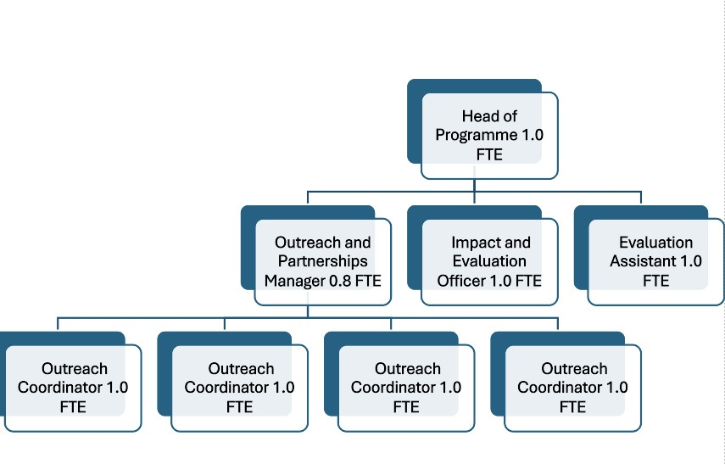

  - The Inspiring Choices programme will be led by the Head of Inspiring Choices, supported by a Research and Impact Evaluation Officer, Outreach and Partnerships Manager. Four Outreach Coordinators will develop close relationships with participating organisations and will support schools and colleges in organising students, arranging activities and supporting school/college/community staff to ensure maximum participation in the programme. An Impact Evaluation Assistant will support the Research and Impact Evaluation Officer with the monitoring and evaluation elements of the programme.

- Governance
  - In addition, the focus and direction of Inspiring Choices will be led by an independently chaired Steering Group. The Group will be responsible for the overall strategic coordination of the project and will also meet three times annually at a minimum and will receive regular reports concerning the programme’s progress and success.
  - The lead institution, York St John University, will receive annual reports concerning all matters relating to the financial performance and controls of the project; the participation rates of schools/colleges/community groups; the participation rates of students; and progress towards achieving objectives.

Part C: Service Specifications

- Engagement

- Inspiring Choices may run activities for the following groups of learners enrolled at the Partners school/college:
  - Young people in Years 10-13 (or equivalent), who live in the 10 North Yorkshire based target wards identified by the OfS and who are likely to achieve 5 9-4 grade GCSEs.
  - Discrete learners in Years 7 to 13 (or equivalent) including Care Experienced young people, adult learners, Gypsy Roma Travellers, disabled learners, military service children and young carers.
  - Young people in Years 7 – 11 (or equivalent) enrolled at the Partner’s school/college who are identified by the school as most in need of interventions that raise academic attainment.
  - Young people in Years 7 – 13 (or equivalent) enrolled at the Partner’s school/college who are identified by the school and Inspiring Choices as most in need of this intervention.

- Activities may include learners from non-target wards and discrete groups where this will benefit the experience of the learners and increase the impact of the activity.

- A formal record of attendance for all funded and non-funded activity for all participants regardless of targeted/discrete learner status will be required by Inspiring Choices on a regular basis and on request.

- Delivery of the programme

- By agreeing to take part in the programme, the school/college will fully engage with Inspiring Choices to devise a programme of activity.

- The resulting activity should contribute to the main purpose of the programme, namely to increase progression to KS5 and ultimately Higher Education. Each activity requires identification within the main framework in collaboration with the Head of Inspiring Choices.

- The school/college will be responsible for ensuring appropriate cohort numbers are provided for each activity and any other logistical arrangements such as cover are made (additional funding will be available for transport for activities).

- Activities and events may be delivered on programme partner campuses, other HE campuses outside the region, within the target school or college, within one of the other target schools or colleges, or within a community setting. Normal school/college procedures should be followed to allow for this with all relevant health and safety policies followed. The school/college is liable for the participants at all supervised events.

- All partners agree to ensure that all activities fully comply with local policies on Diversity and Equality by eliminating discrimination and promoting equality with regard to any of the protected characteristics as stated in the Equality Act 2010. The school/college must inform Inspiring Choices of any accessibility requirements for participants in advance of any events/activities delivered by Inspiring Choices or an approved third party.

- Monitoring and Audit

- Schools/colleges will agree to a Data Sharing Agreement covering target ward participants engaging in programme activity as well as general cohort data. The data provided will only be used for monitoring and research purposes unless specified and agreed. Inspiring Choices will adhere to the data protection polices and guidelines of York St John University. Data will be provided at the beginning of the academic year.

- All of our activities are subject to rigorous review and evaluation with a view to, in the future, either repeating them (subject to resource availability), improving them before reintroduction, or deleting them from the programme of activity for reasons of lack of impact or relevance.

- The funding body (OfS) requires thorough monitoring and evaluative evidence, therefore the Partner will be required to provide a variety of information as well as participant data to use in formal reporting back to OfS such as:

- Provision of data to Inspiring Choices (directly or through the partner organisation) on learner profiles (personal characteristics/attainment/changes in progress etc.)
- Annual school activity report detailing activity and participant data with organisations outside of the partnership.
- Any additional requests required to show the success of the programme or evaluation of the cohort

- Individual organisations, such as the partner higher education institutions will be required to collect data on individuals participating in activities. The data will be used to track participants unless authorisation is gained from the individual to use the data for personal correspondence, relating to the aims of the programme.

- Management and Delivery
- Inspiring Choices will require two main points of contact, one person who sits on the School Leadership Team (SLT) and one person who will be the operational lead to assist with the delivery of the programme. If the latter is part of the SLT, then one contact will suffice.
- The main operational contact(s) should have the authority to undertake the following:
- Identify and access target ward learners and wider cohorts for activity and provide this data to Inspiring Choices
- Coordinate cohort activity on and off school/college/university premises, ensuring associated protocols are followed
- Allow Inspiring Choices and partners access to appropriate space to deliver activities required
- Be able to handle data queries, or know who to direct such queries to
- Be able to assist with the audit of current provision and mapping of future provision (based on academic calendars and other school/college/university-based commitments)
- To involve the SLT member when appropriate to gain SLT agreement when required

- Partners, where reasonable should provide access to equipment and space within institutions or premises.
- Partners should ensure that activities are efficiently evaluated at a local level and as part of national evaluation requirements (where required) and shared with Inspiring Choices as appropriate.

- Problems, Complaints and Remedies
- Our expectation is that partners involved in the Inspiring Choices project commit to working with the team to endeavour to achieve our key aims and targets. This means that if problems or issues do arise we would expect there to be an opportunity to work in partnership to remedy them at the first available opportunity.
- Parties will maintain a dialogue and keep communication channels open to ensure that any problem or complaint is addressed at the appropriate level at the earliest opportunity.

- Issues should be reported to the Outreach and Partnerships Manager initially, with the potential for escalation to the Advisory Board if necessary.
- Inspiring Choices will be responsible for initiating formal procedures to deal with complaints that are of a serious nature, utilising existing disciplinary and grievance procedures.

This agreement has been entered into on the date that it is signed by both parties.

- Signatures
On behalf of the University
Signature: 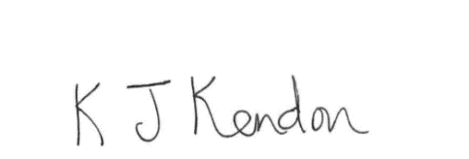
Name: Kathryn Kendon
Job Title: University Secretary and Registrar
Date: 03/06/25

On behalf of the Partner – SLT Contact
Signature: _____________________________________________________________
Name: _____________________________________________________________
Job Title: _____________________________________________________________
Date: _____________________________________________________________

On behalf of the Partner – Operational Staff Contact (Optional)
Signature: _____________________________________________________________
Name: _____________________________________________________________
Job Title: _____________________________________________________________
Date: _____________________________________________________________

